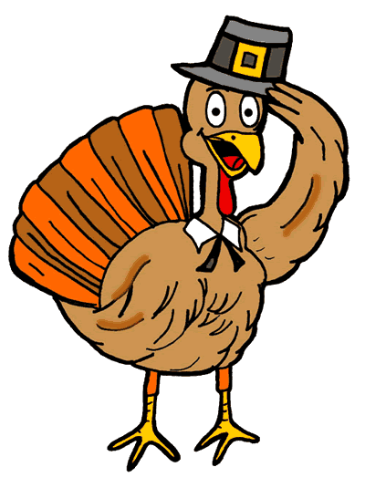
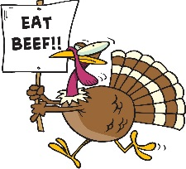
TURKEY SHOOT

RIFLE SPORTSMEN’S CLUB

The annual trap turkey shoot is
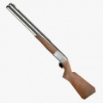
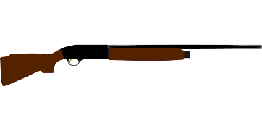
happening Sunday the 24th

Shooting starts @ 10:00 am

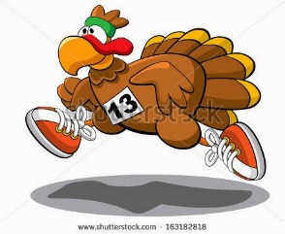
Lots of prises and a whole lot of fun!
Range location is north of Hwy. 13
on Fravert Reservoir Rd.
General public is welcome
7 ½ and 8 shot only
Will be shooting trap and shotgun games
Cost is $7.00 per round or game
Contact Brian Perkins 618-3546 with questions
bperkins2@comcast.net
www.riflegunclub.com

